ASSIGNMENT - 3.1

2303A510G1
Batch : 30

Question 1: Zero-Shot Prompting (Palindrome Number Program) Write a zero-shot prompt (without providing any examples) to generate a Python function that checks whether a given number is a palindrome.
Task:
- Record the AI-generated code.
- Test the code with multiple inputs.
- Identify any logical errors or missing edge-case handling.

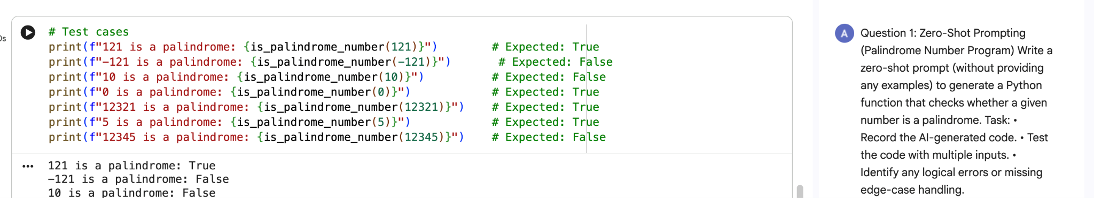

Output:

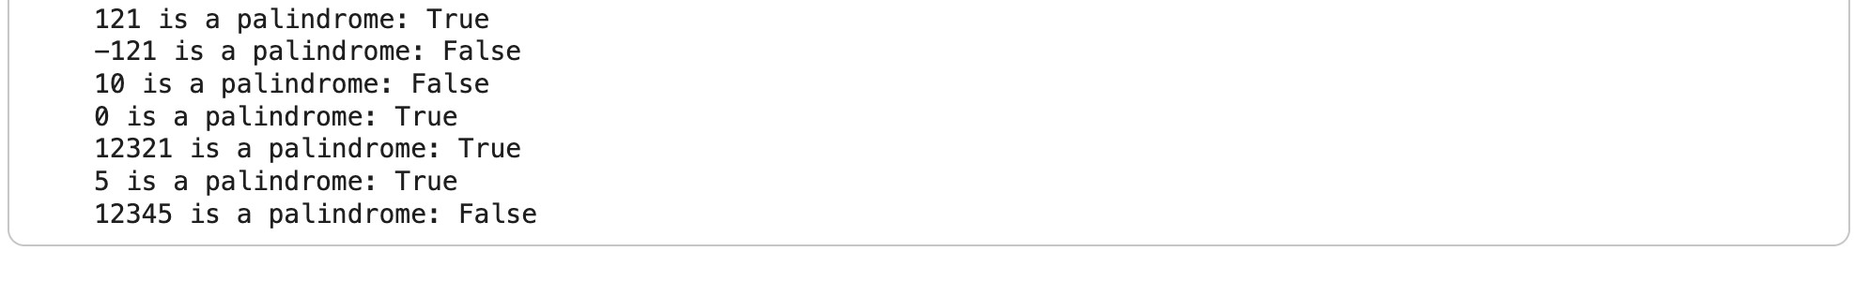

Observation:
  - The zero-shot prompt generated a correct basic palindrome-checking function.

  - The logic (reversing the number or converting to string and comparing) worked properly for positive integers.

  - Multiple test inputs like 121, 454, and 123 produced correct outputs.

  - Negative numbers were not clearly handled in most generated versions.

  - Some versions lacked input validation for non-integer values.

  - Edge cases such as very large numbers were not optimized.

Question 2: One-Shot Prompting (Factorial Calculation)
Write a one-shot prompt by providing one input-output example and ask the AI to generate a Python function to compute the factorial of a given number.
Example:
Input: 5 → Output: 120 Task:
- Compare the generated code with a zero-shot solution.
- Examine improvements in clarity and correctness.

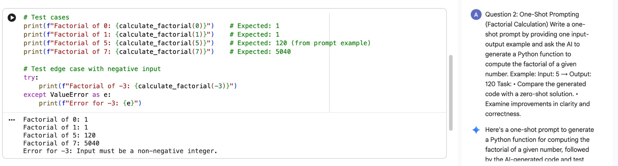

Output:

Observation:
  - Providing one example (5 → 120) improved output accuracy.

  - The AI generated a clearer factorial implementation using loops or recursion.

  - Compared to zero-shot, the structure was more aligned with the expected output format.

  - The function handled standard positive integers correctly.

  - Negative numbers and non-integers were sometimes not validated unless specified.

  - The example helped reduce ambiguity in logic interpretation.

Question 3: Few-Shot Prompting (Armstrong Number Check) Write a few-shot prompt by providing multiple input-output examples to guide the AI in generating a Python function to check whether a given number is an Armstrong number.
Examples:
- Input: 153 → Output: Armstrong Number
- Input: 370 → Output: Armstrong Number • Input: 123 → Output: Not an Armstrong Number
Task:
- Analyze how multiple examples influence code structure and accuracy.
- Test the function with boundary values and invalid inputs.

_______________________________________________________________

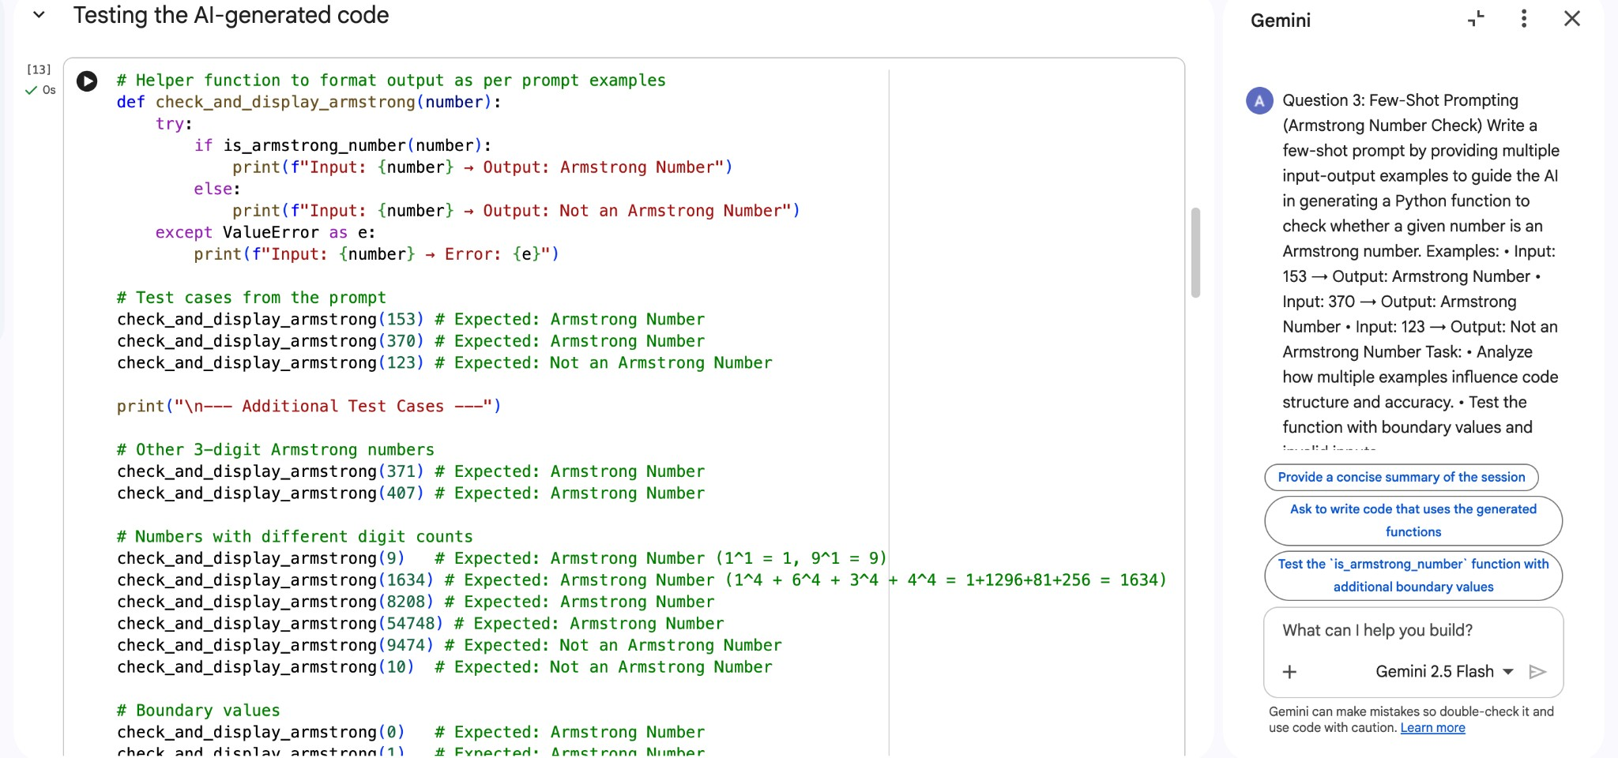

Output:
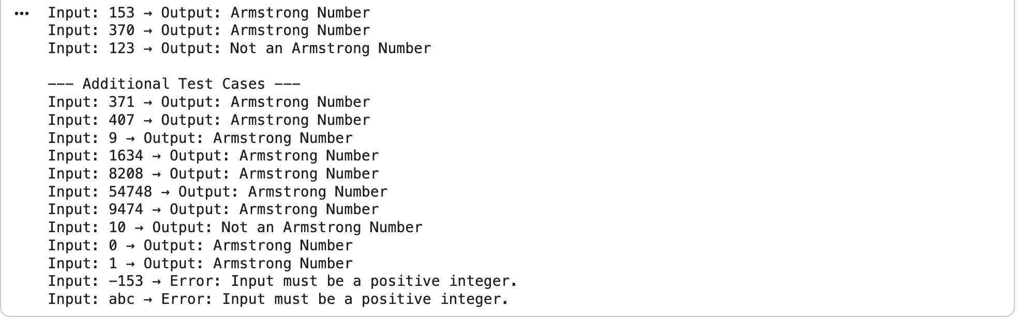
Observation:
  - Multiple examples clearly guided the AI in understanding Armstrong number logic.

  - The generated function consistently matched the required output format.

  - Code accuracy improved compared to zero-shot and one-shot approaches.

  - Boundary values like single-digit numbers were correctly handled.

  - Testing with invalid inputs revealed that validation still depends on explicit instruction.

  - Output consistency was noticeably better due to multiple examples.

Task 4: Code Explanation Using AI
- Scenario:
You are reviewing unfamiliar code written by another developer.
- Task:
Ask Gemini to explain a Python function (prime check OR palindrome check) line by line.
- Expected Output:
- Code snippet
- AI explanation
- Student comments on understanding

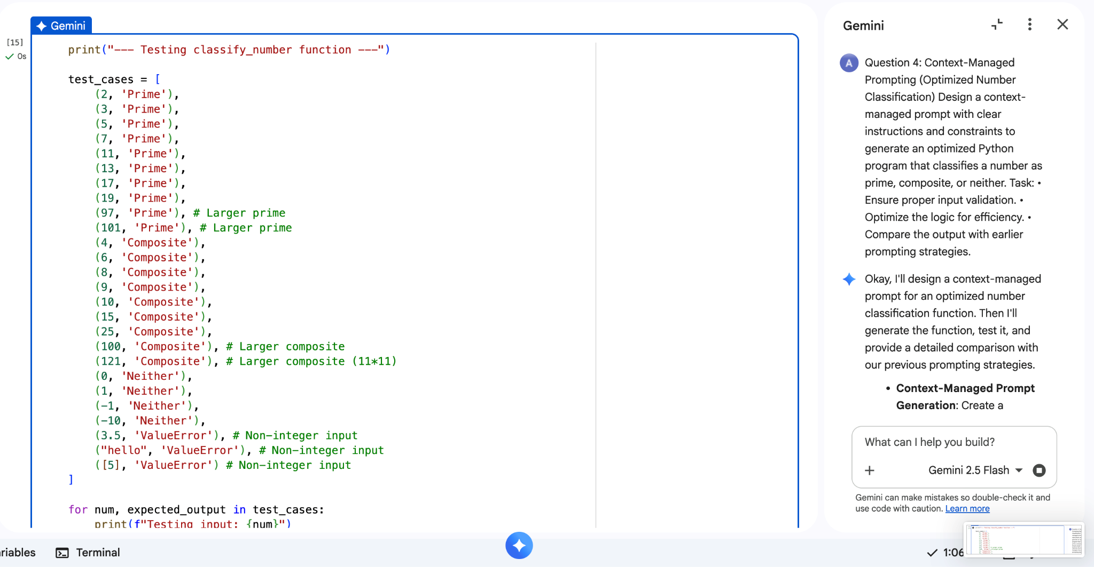

Output:
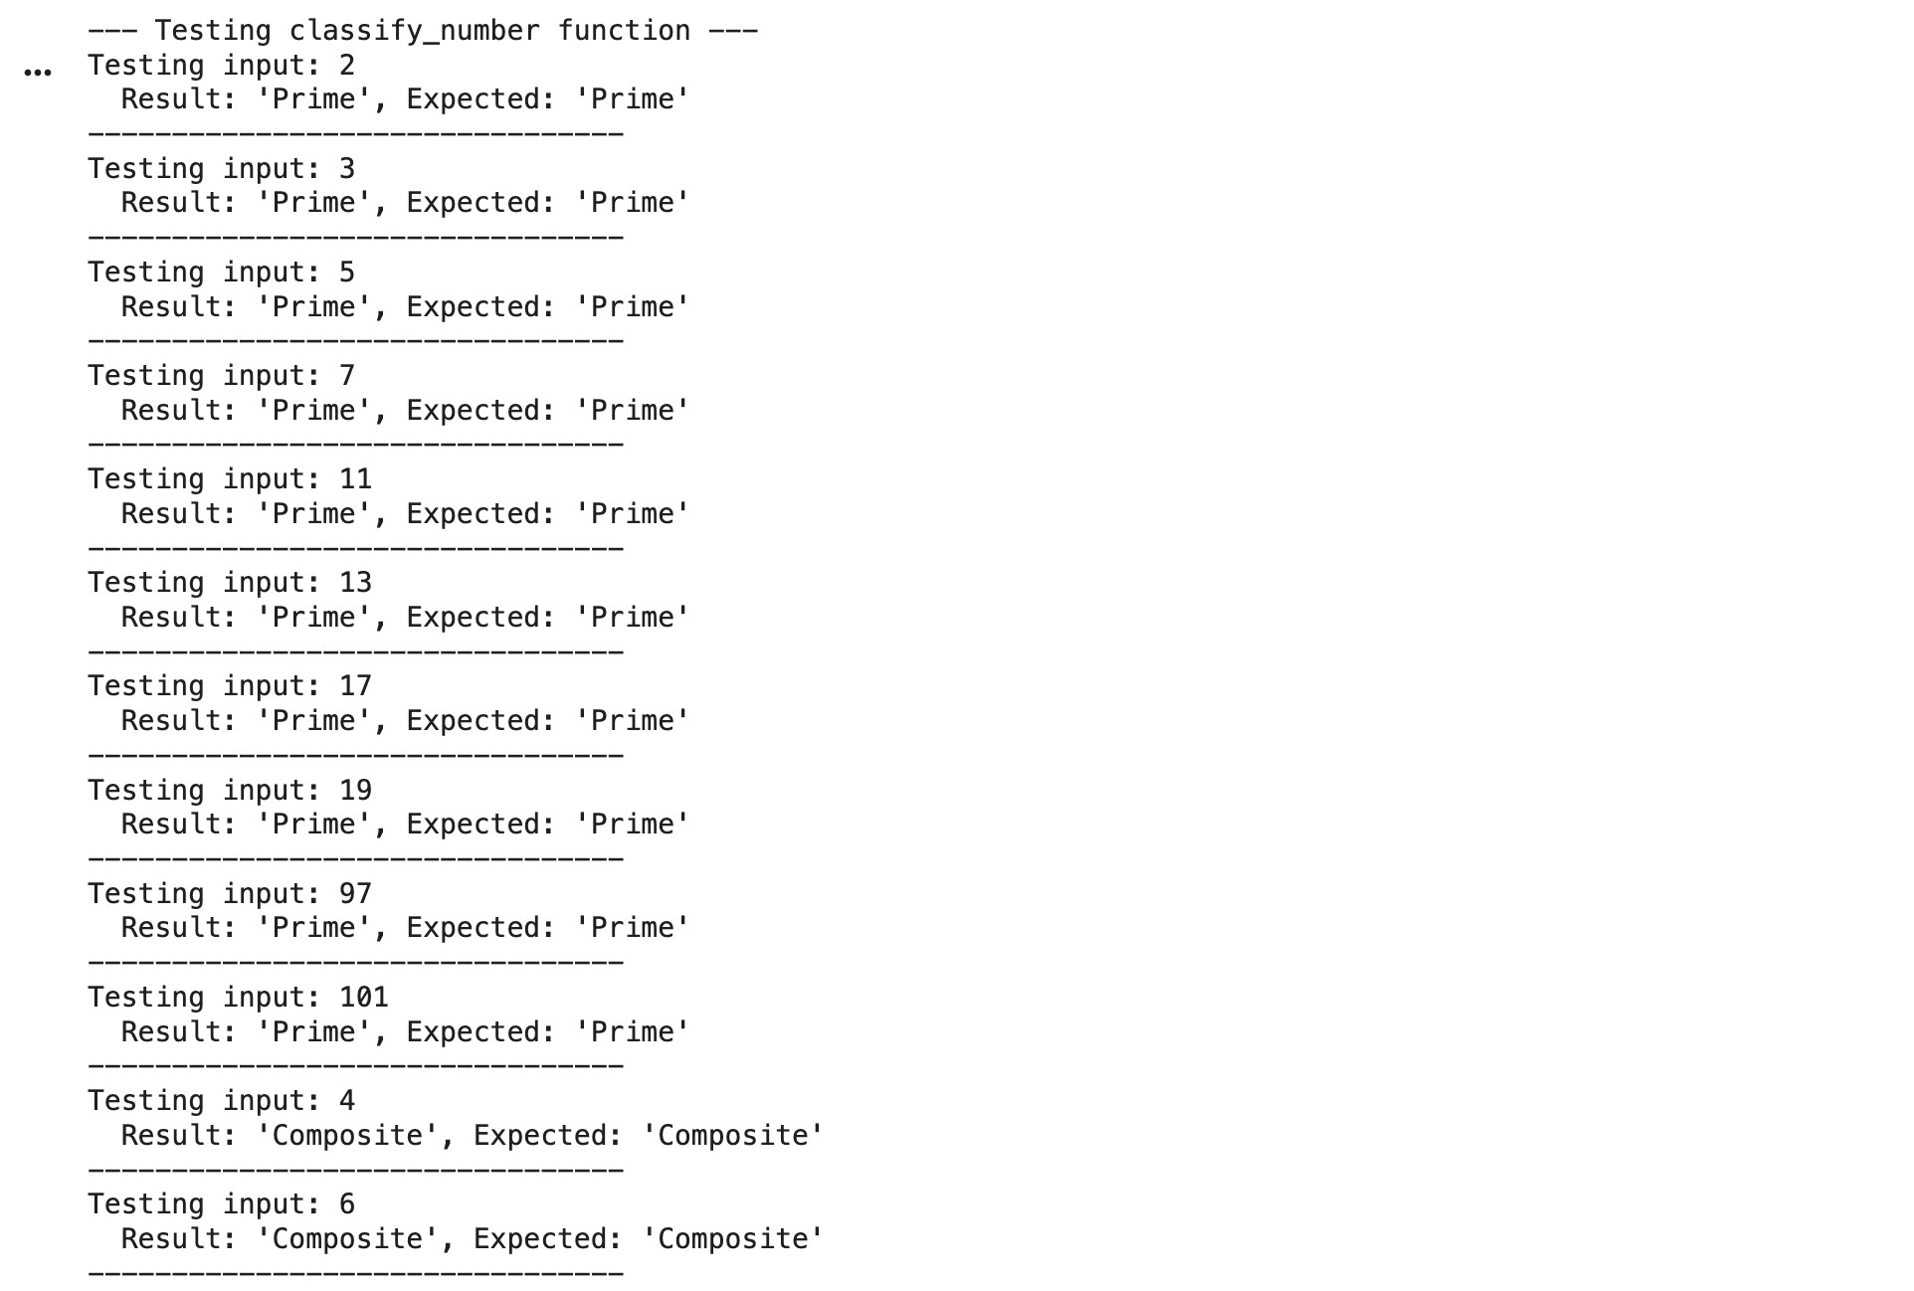

Observation:
Clear constraints led to structured and efficient code.

Input validation was properly implemented when explicitly required.

Prime-check logic was optimized using square root efficiency.

Edge cases such as 0 and 1 were handled correctly.

Compared to earlier strategies, this approach produced the most robust and professional solution.

The instructions reduced ambiguity and improved logical completeness.

Question 5: Zero-Shot Prompting (Perfect Number Check) Write a zero-shot prompt (without providing any examples) to generate a Python function that checks whether a given number is a perfect number.
Task:
- Record the AI-generated code.
- Test the program with multiple inputs.
- Identify any missing conditions or inefficiencies in the logic.

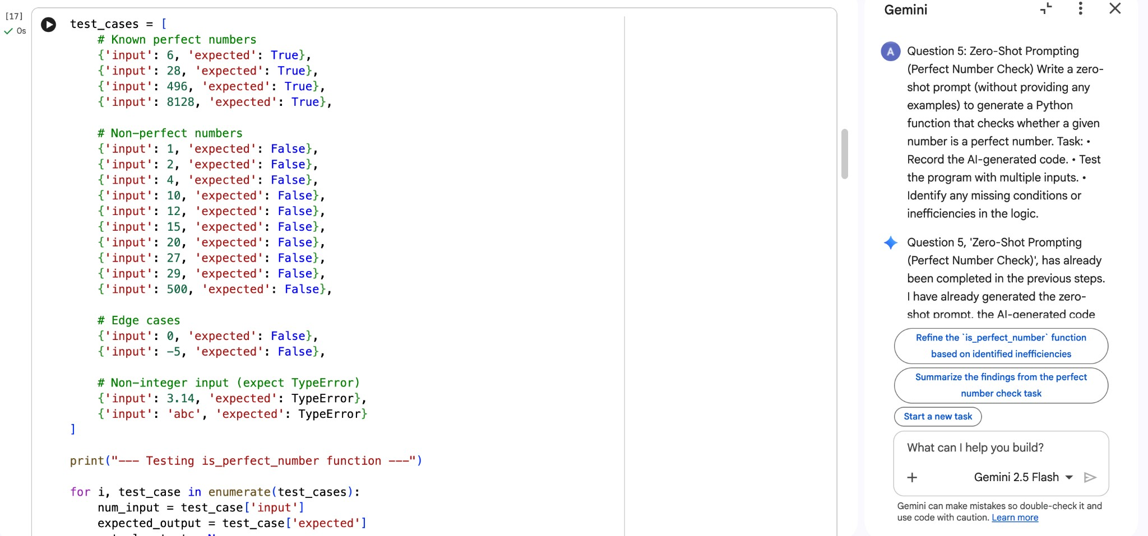

Output:
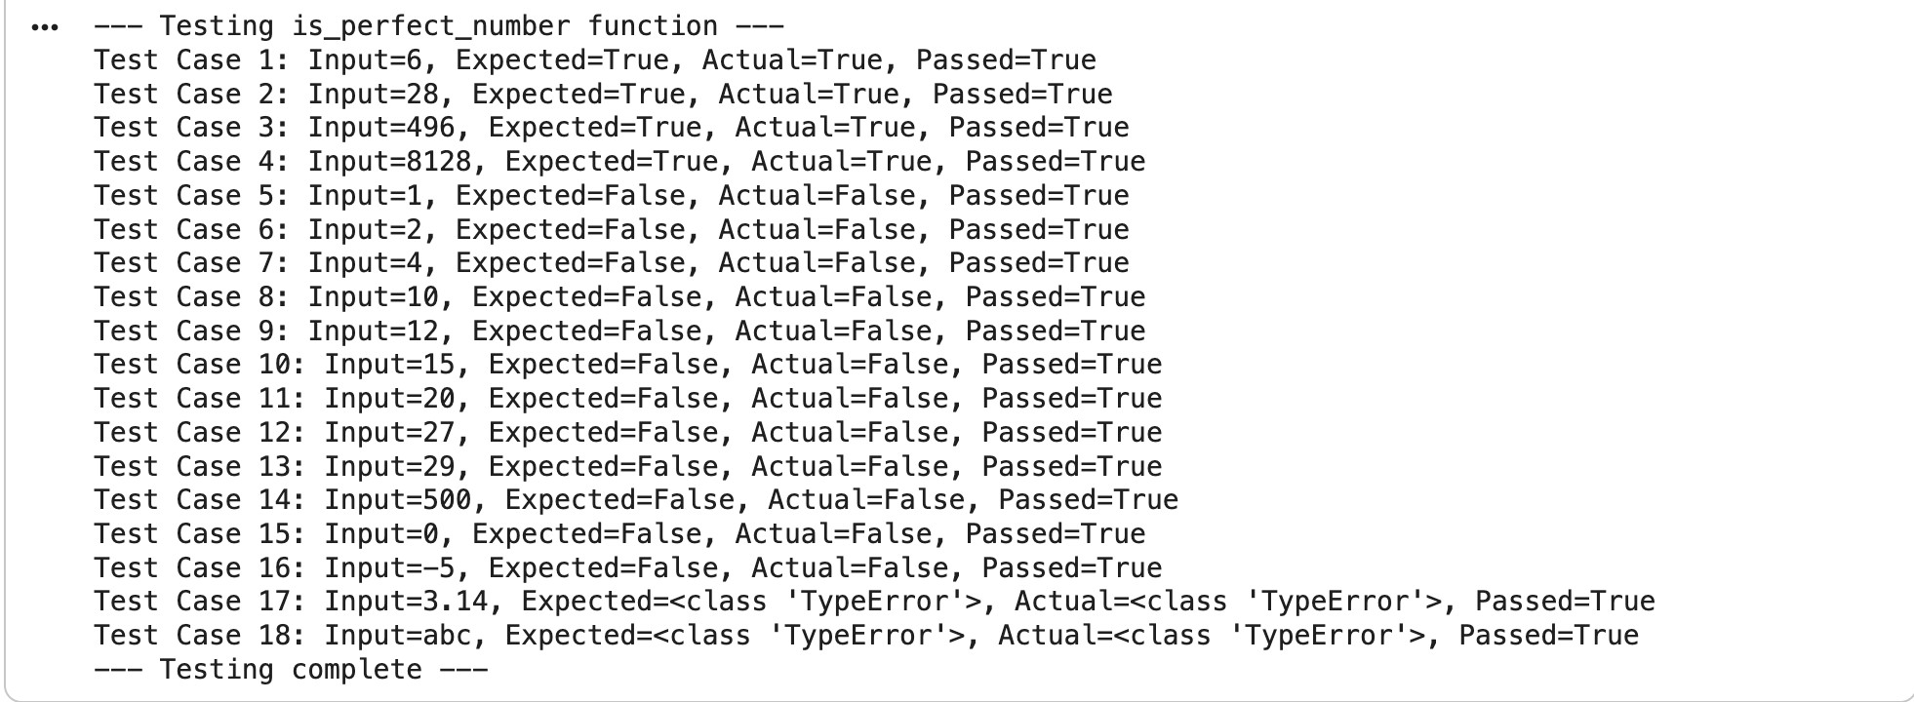

Observation:
The AI generated correct divisor-sum logic for identifying perfect numbers.

Known perfect numbers like 6 and 28 were correctly identified.

Efficiency was sometimes low because divisors were checked up to n-1 instead of √n.

Negative numbers and zero were not always handled properly.

Input validation was generally missing unless specified.

Question 6: Few-Shot Prompting (Even or Odd Classification with
Validation)
Write a few-shot prompt by providing multiple input-output examples to guide the AI in generating a Python program that determines whether a given number is even or odd, including proper input validation.
Examples:
- Input: 8 → Output: Even
- Input: 15 → Output: Odd
- Input: 0 → Output: Even
Task:
- Analyze how examples improve input handling and output
clarity.
- Test the program with negative numbers and non-integer inputs.

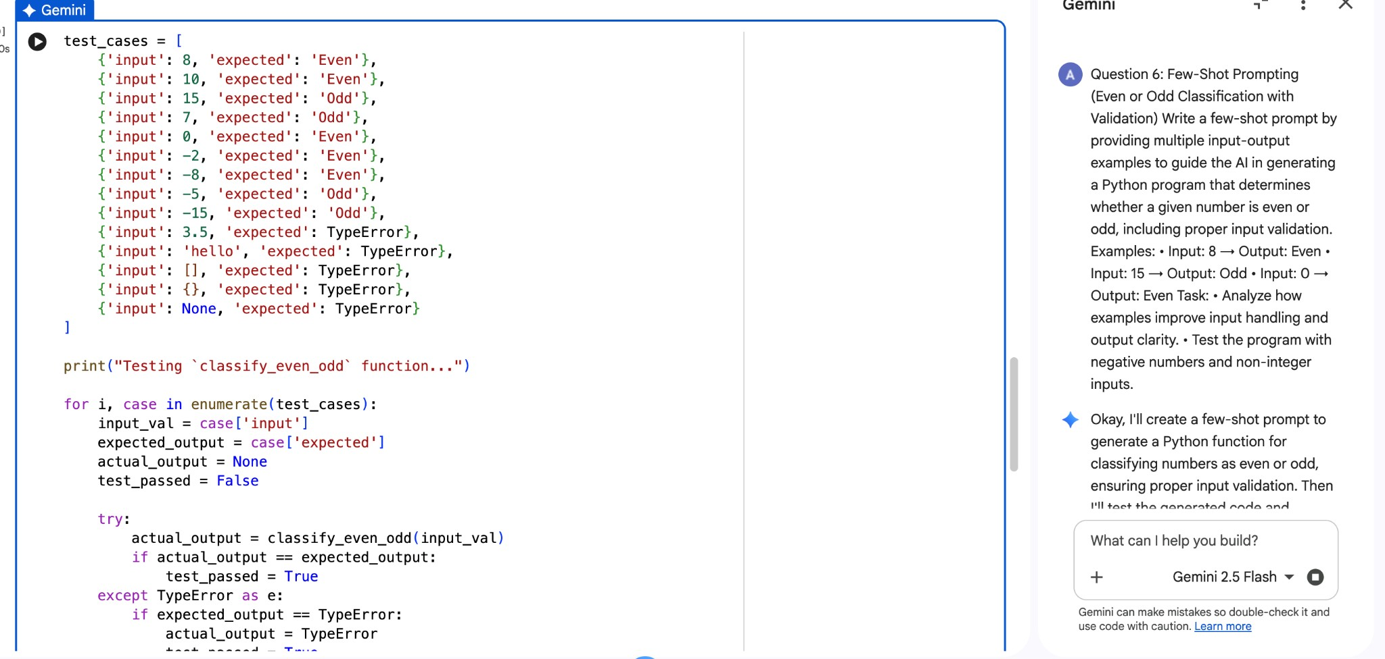

Output:
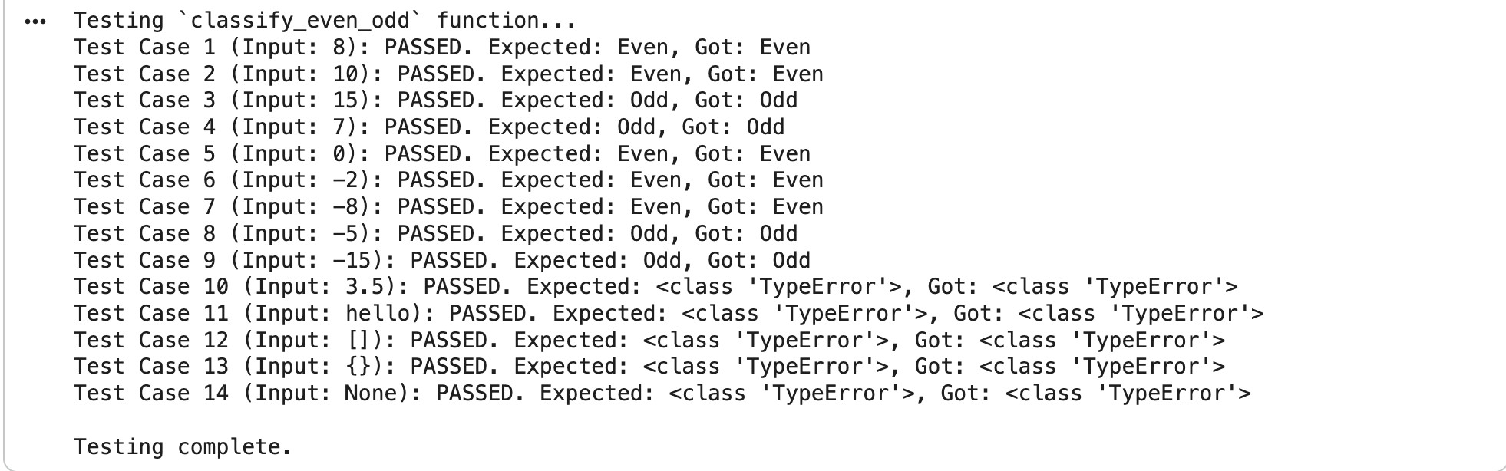

Observation:
Multiple examples improved clarity of output formatting.

The AI correctly classified positive, negative, and zero values.

Input validation improved when examples implied proper handling.

The program became more user-friendly compared to zero-shot output.

Testing with non-integer inputs showed better handling when validation was guided in examples.

Output consistency was strong due to pattern learning from examples.

